**Front-End UI/UX Mini Project**

**1. Title Page**

* **Project Title**: *Restaurent Landing Page*
* **Name:** ALVIN JOBI , JOSHUA SANTOSH , JOSEPH MANGALY , SAVIO JOSE
* **Reg. No.:** 2463005 , 2463032 , 2463031 , 2463051
* **Program:** B.Tech in Artificial Intelligence and Machine Learning
* **Semester:** 3rd
* **Institution:** Christ University, Kengeri
* **Academic Year:** 2025

**2. Abstract**

This project presents the development of a responsive and visually engaging personal portfolio website titled *HELL'S KITCHEN – Fine Dining & Comfort Food*. Designed using HTML and CSS, the website showcases modern web design principles with a focus on user experience, accessibility, and aesthetic coherence. It features multiple sections including a dynamic hero banner, curated menu listings, an about page, contact form, and newsletter subscription—all integrated into a cohesive layout.

The site employs semantic HTML5 structure and custom CSS styling, enhanced by Google Fonts and Font Awesome icons to elevate visual appeal. A consistent color palette and typographic hierarchy ensure readability and brand identity. The layout adapts seamlessly across devices using responsive design techniques, while interactive elements such as hover effects and CSS-only lightbox functionality enrich user interaction.

This portfolio not only demonstrates technical proficiency in front-end development but also reflects thoughtful design choices that prioritize clarity, usability, and storytelling. It serves as a digital showcase for culinary branding, with potential applications in restaurant marketing, hospitality outreach, and personal branding.

**3. Objectives**

The primary goals of this project are:

* **Design a user-friendly interface** using modern UI principles to enhance user experience and engagement
* **Develop a fully responsive layout** using only HTML and CSS to ensure compatibility across desktops, tablets, and mobile devices
* **Implement structured HTML5 semantic elements** for better readability, maintainability, and SEO optimization
* **Apply CSS styling** for consistent branding, visual layout, and responsive behavior across all pages
* **Ensure accessibility and readability** by following web standards and best practices for inclusive design

**4. Scope of the Project**

This project outlines the boundaries and focusses areas as follows:

* **Focused on front-end design only**, emphasizing layout, structure, and visual presentation
* **No JavaScript or server-side integration** was included; the project is purely static and client-side
* **Intended for desktop, tablet, and mobile viewports**, ensuring responsive behavior across common screen sizes
* **Used only open-source tools and pure code**, relying solely on HTML5 and CSS3 without external libraries or frameworks

**5. Tools & Technologies Used**

|  |  |
| --- | --- |
| Tool/Technology | Purpose |
| HTML5 | Markup and content structure |
| CSS3 | Styling and layout management |
| VS Code | Code editor |
| Chrome DevTools | Testing and debugging |

**6. HTML Structure Overview**

* Used semantic tags: <header>, <nav>, <main>, <section>, <footer>
* Structured into reusable sections: About, Projects, Contact
* Navigation menu using <ul> and anchor links for smooth scrolling

**7. CSS Styling Strategy**

The styling approach for this project was guided by the following principles:

* **Used a mobile-first design strategy**, ensuring optimal performance and layout on smaller screens before scaling up
* **Applied consistent typography and color schemes** to maintain visual identity and readability throughout the site
* **Utilized CSS Grid and Flexbox** for responsive layout structures and dynamic content alignment
* **Implemented hover effects and transitions** to enhance interactivity and user engagement
* **Ensured modular and reusable styles** by organizing CSS rules around semantic HTML elements and class-based selectors

**8. Key Features**

|  |  |
| --- | --- |
| Feature | Description |
| Responsive Design | Adapts seamlessly to all screen sizes |
| Smooth Navigation | Fixed top nav with anchor links |
| Project Cards | Flex-based layout with hover effects |
| Contact Form (non-functional) | Placeholder layout for inputs and button |
| Accessible Fonts & Colors | High contrast and readable typography |

**9. Challenges Faced & Solutions**

|  |  |
| --- | --- |
| Challenge | Solution |
| Overlapping elements on small screens | Used media queries to stack elements |
| Difficulty aligning items using float | Shifted to Flexbox and Grid |
| Typography scaling issue | Used relative units (em/rem) instead of px |

**10. Outcome**

* Achieved a clean, consistent, and visually engaging front-end layout
* All key components function as intended using just HTML and CSS
* Learned about layout responsiveness and UI hierarchy in depth

**11. Future Enhancements**

To further improve the functionality and user experience of the portfolio website, the following enhancements are proposed:

* **Integrate JavaScript** to add dynamic features such as animations, form validation, and interactive elements
* **Implement a backend system** using technologies like Node.js or PHP to enable contact form submissions and content management
* **Add a blog section** to share technical insights, tutorials, and project updates
* **Include dark mode support** for improved accessibility and user preference
* **Optimize for SEO** by adding meta tags, structured data, and performance improvements
* **Deploy on a custom domain** with HTTPS for professional presentation and security
* **Enable multilingual support** to reach a broader audience

**12. Sample Code**

**/* Reset default margin and padding for all elements */**

**\* {**

**margin: 0;**

**padding: 0;**

**box-sizing: border-box; /* Ensures consistent box sizing across elements */**

**}**

**/* Base body styling */**

**body {**

**font-family: 'Poppins', sans-serif; /* Sets font style */**

**line-height: 1.6; /* Improves readability */**

**background-color: #f9f9f9; /* Light background color */**

**color: #333; /* Dark text color for contrast */**

**}**

**/* ===================== Navigation ===================== */**

**/* Header styling */**

**header {**

**background: #004aad; /* Blue background */**

**color: white; /* White text */**

**padding: 1rem 0; /* Vertical padding */**

**position: sticky; /* Sticks to top on scroll */**

**top: 0;**

**z-index: 10; /* Ensures it stays above other content */**

**}**

**/* Navigation container */**

**nav {**

**max-width: 1100px; /* Limits width */**

**margin: auto; /* Centers nav */**

**display: flex; /* Flex layout for horizontal alignment */**

**justify-content: space-between; /* Space between logo and links */**

**align-items: center; /* Vertically center items */**

**padding: 0 20px; /* Horizontal padding */**

**}**

**/* Site title styling */**

**nav h2 {**

**font-weight: 600; /* Bold title */**

**}**

**/* Navigation links */**

**nav a {**

**color: white; /* White text */**

**text-decoration: none; /* Removes underline */**

**margin: 0 15px; /* Spacing between links */**

**font-weight: 500; /* Medium font weight */**

**}**

**/* Hover effect for links */**

**nav a:hover {**

**text-decoration: underline; /* Adds underline on hover */**

**}**

**/* ===================== Hero Section ===================== */**

**.hero {**

**text-align: center; /* Center-align content */**

**padding: 2rem; /* Adds spacing around hero section */**

**}**

**/* Profile image styling */**

**.hero img {**

**width: 150px; /* Fixed width */**

**border-radius: 50%; /* Circular image */**

**}**

**/* Hero heading */**

**.hero h1 {**

**margin-top: 1rem; /* Space above heading */**

**font-size: 2rem; /* Larger font size */**

**}**

**/* ===================== Section Layout ===================== */**

**section {**

**max-width: 1100px; /* Limits width */**

**margin: 2rem auto; /* Vertical spacing and center alignment */**

**padding: 0 20px; /* Horizontal padding */**

**}**

**/* Grid layout for projects */**

**.projects-grid {**

**display: grid; /* Enables grid layout */**

**grid-template-columns: repeat(auto-fit, minmax(250px, 1fr)); /* Responsive columns */**

**gap: 20px; /* Space between grid items */**

**}**

**/* Individual project card styling */**

**.project-card {**

**background: white; /* White background */**

**padding: 1rem; /* Internal spacing */**

**border-radius: 8px; /* Rounded corners */**

**box-shadow: 0 2px 5px rgba(0,0,0,0.1); /* Subtle shadow */**

**text-align: center; /* Center-align text */**

**}**

**/* Project image styling */**

**.project-card img {**

**width: 100%; /* Full width of card */**

**border-radius: 5px; /* Slightly rounded corners */**

**}**

**/* ===================== Buttons ===================== */**

**/* Styling for buttons and submit inputs */**

**button, input[type=submit] {**

**background: #004aad; /* Blue background */**

**color: white; /* White text */**

**border: none; /* No border */**

**padding: 10px 20px; /* Internal spacing */**

**cursor: pointer; /* Pointer cursor on hover */**

**border-radius: 5px; /* Rounded corners */**

**}**

**/* Hover effect for buttons */**

**button:hover, input[type=submit]:hover {**

**background: #003080; /* Darker blue on hover */**

**}**

**/* ===================== Contact Form ===================== */**

**/* Form layout */**

**form {**

**display: grid; /* Grid layout for form fields */**

**gap: 10px; /* Space between fields */**

**}**

**/* Input and textarea styling */**

**input, textarea {**

**padding: 8px; /* Internal spacing */**

**border: 1px solid #ccc; /* Light border */**

**border-radius: 5px; /* Rounded corners */**

**}**

**/* ===================== Footer ===================== */**

**footer {**

**text-align: center; /* Center-align text */**

**padding: 1rem; /* Internal spacing */**

**background: #004aad; /* Blue background */**

**color: white; /* White text */**

**margin-top: 2rem; /* Space above footer */**

**}**

**/* Footer link styling */**

**footer a {**

**color: white; /* White text */**

**margin: 0 10px; /* Spacing between links */**

**}**

**/* ===================== Smooth Scrolling ===================== */**

**html {**

**scroll-behavior: smooth; /* Enables smooth scroll effect */**

**}**

**/* ===================== Responsive Design ===================== */**

**/* Responsive navigation layout for smaller screens */**

**@media (max-width: 768px) {**

**nav {**

**flex-direction: column; /* Stack nav items vertically */**

**text-align: center; /* Center-align text */**

**}**

**}**

**13. Screenshots of Final Output**

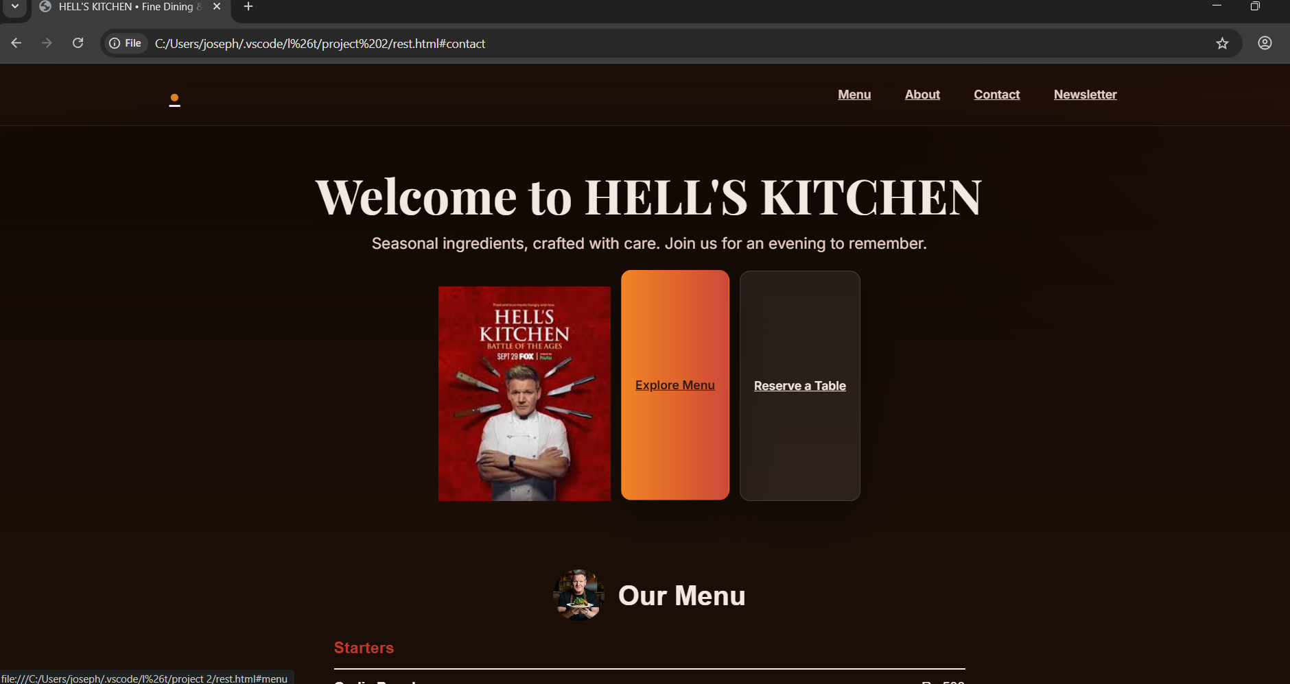

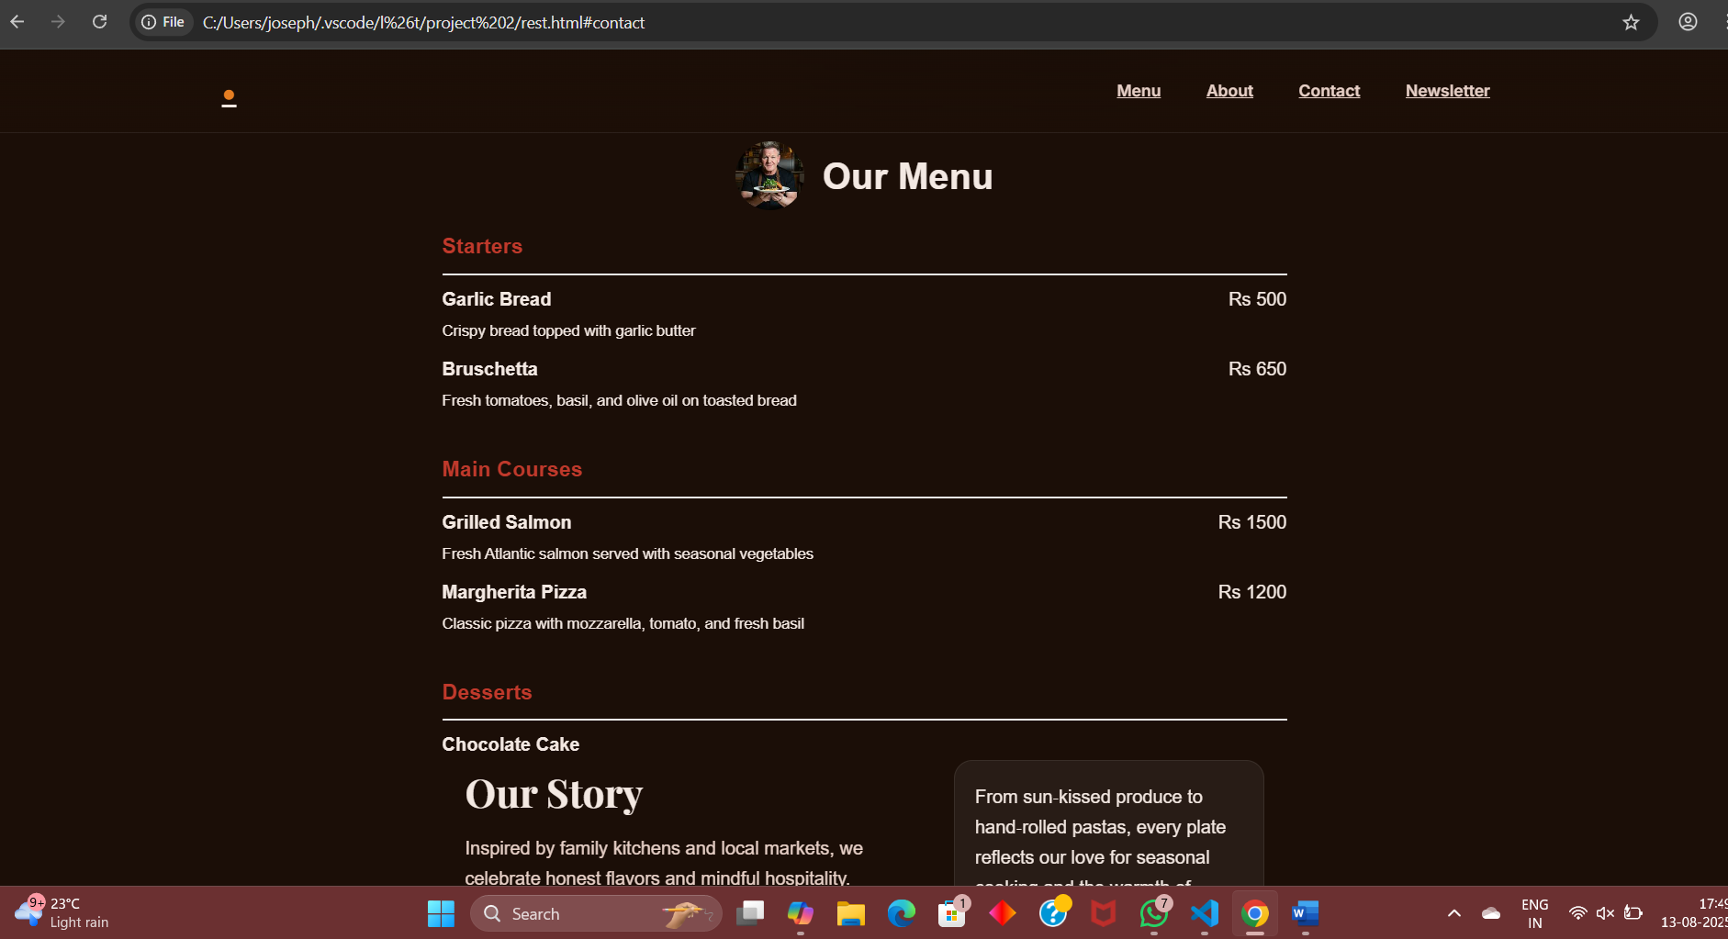

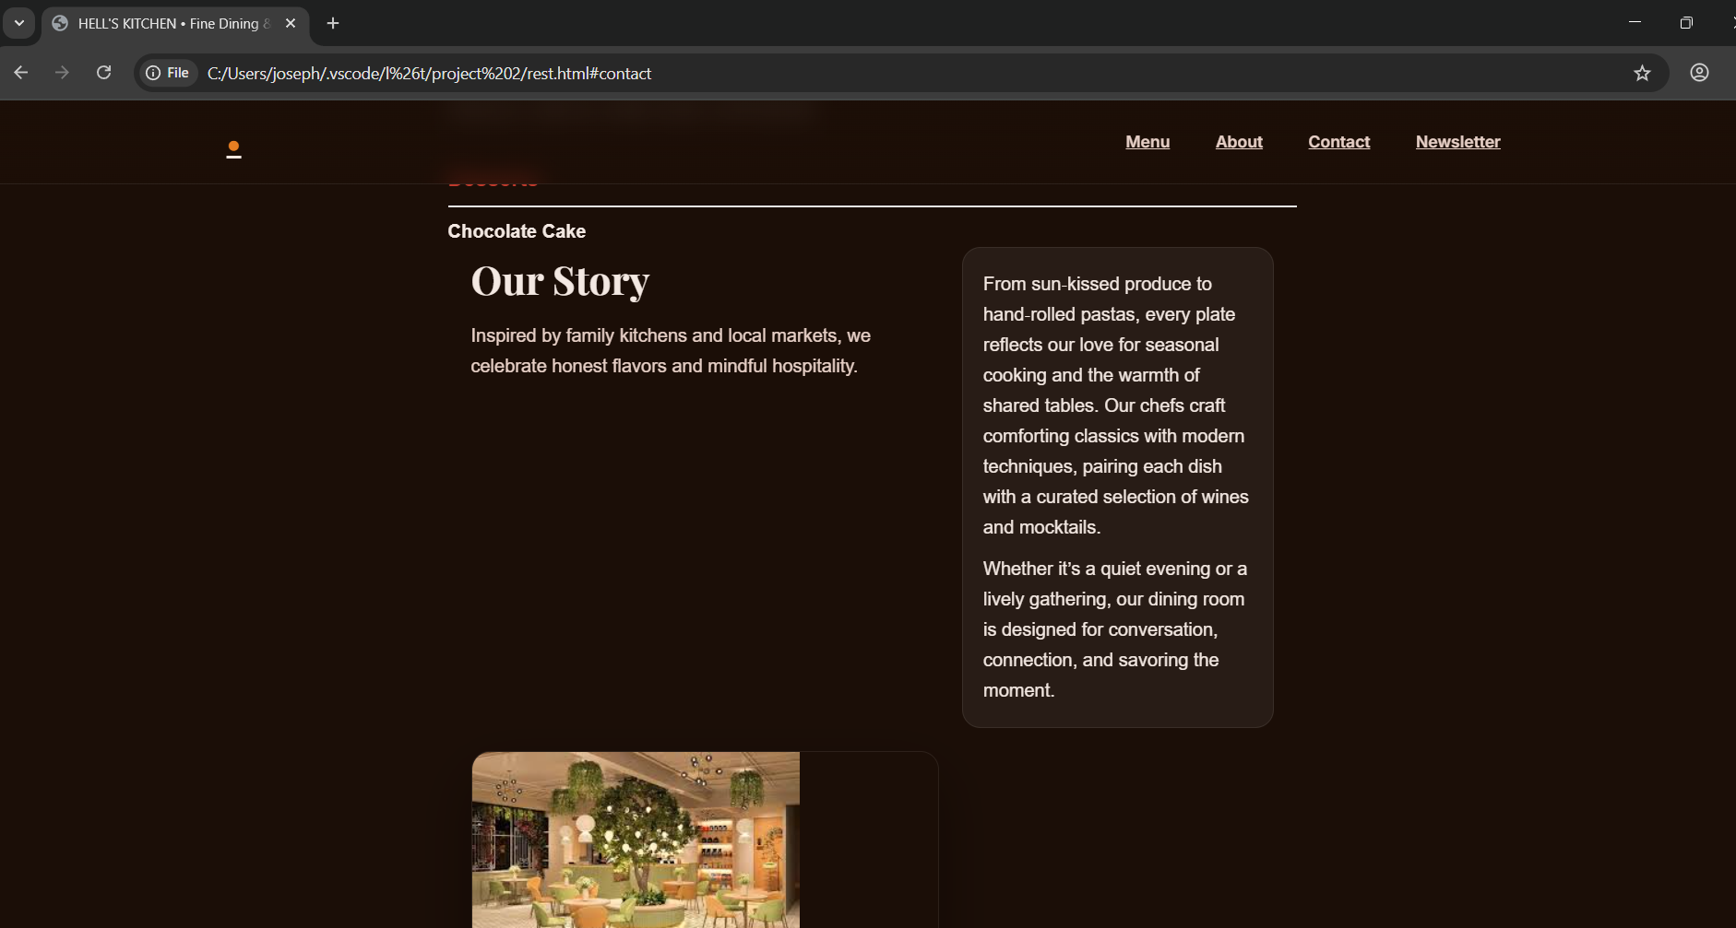

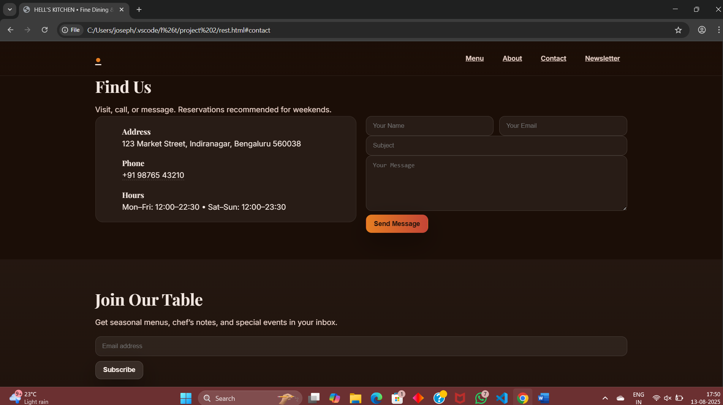

**14. Conclusion**

The personal portfolio website developed using HTML and CSS successfully fulfills its intended purpose of presenting the developer’s profile, skills, and projects in a structured and visually appealing manner. By implementing a responsive layout, semantic HTML elements, and clean CSS styling, the project demonstrates proficiency in front-end web development and modern design principles. The site is accessible across devices, easy to navigate, and serves as a professional platform for showcasing technical capabilities. This project not only enhances the developer’s digital presence but also lays a strong foundation for future enhancements such as interactivity, backend integration, and SEO optimization.

**15. References**

* W3Schools HTML & CSS Documentation
* Mozilla Developer Network (MDN)